**Angeles  City Science High School**

**Conchem 9**

Name:Paul Gerald D. Pare  Section:9 - Adenine

# *What’s More*

## Activity 1. History of Cosmetics

**Direction:** Complete the historical timeline about the development of cosmetics. Write the chemicals or materials used by the people involved in the picture during the early times.

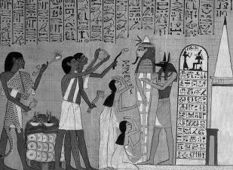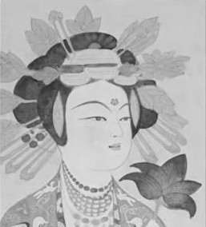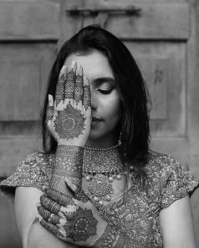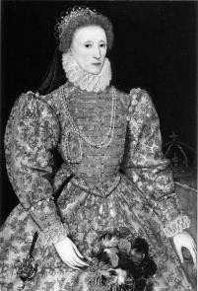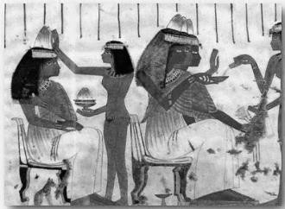

1. Egg white
2. Henna
3. Malachite, Galena Mesdemet
4. White Lead Paint
5. Gum arabic, Gelatin, Beeswax, egg

**Example:** myrrh, thyme, marjoram, chamomile, lavender, lily, peppermint, rosemary, cedar, rose, aloe, olive oil, sesame oil, and almond oil as perfume

## Activity 2. Our Cosmetics at Home

Cleanliness should always start at home and with one’s self. This activity will help you practice identifying the different cosmetic product forms. So let us start by looking around your house. List down the available cosmetic products and identify their cosmetic product form.

|  |  |
| --- | --- |
| **COSMETIC PRODUCTS**  **PRESENT AT HOME** | **COSMETIC PRODUCT FORM** |
| Perfume |  |
|  |  |
|  |  |
|  |  |
|  |  |
|  |  |
|  |  |
|  |  |

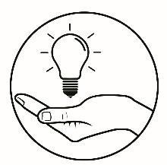

# *What I Have Learned*

Let us check if you already know the different cosmetic product forms. Identify the best product form **(liquid, gel, foaming gel, serum, lotion, cream, powder, balm, mud, scrub**) and uses of the different cosmetic items below. **Note:** Choose only 5 items to answer.

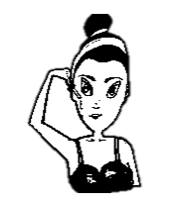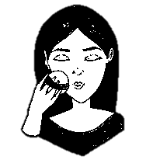

2. Cosmetic Product:

Cosmetic Product Form: Uses:

1. Cosmetic Product: Skin Care Cream

Cosmetic Product Form: Cream

Uses: Gives light and natural look on your skin.